**Creating Actionable Insights Using TableauCRM (Einstein Analytics)**

PART 1: What is TCRM and where can you use it?

The reader will have a clear understanding of what TCRM is and what it is used for, and how to identify suitable business use cases.

**CHAPTER 1:** What is TCRM and where can you use it?  
- 30 pages

DESCRIPTION:

This introductory chapter will begin right at the start – what is TCRM? This is vital because it will make sure the reader begins on the right foot with a correct understanding of the fundamentals of TCRM. The reader will also evaluate his/her business or organisation and identify how and where TCRM will provide value in terms of a business outcome. This includes reviewing business challenges, problems, and opportunities in light of how data and analytics could impact these, as well as evaluating the limitations of existing systems, processes and people.

Level: Basic

Main Chapter Headings (3-5 main chapter headings)

1. HEADING 3: What is TCRM?
2. HEADING 1: Room for Improvement
3. HEADING 2: Bigger than oil
4. HEADING 3: Why TCRM?

Skills learned: *For each heading, insert what the reader will learn to DO in this chapter?*

1. SKILL 1: Understand and define data, analytics, and TCRM
2. SKILL 2: Understand and appreciate the tremendous value of data insights
3. SKILL 3: Identify and target high priority use cases for TCRM

# CHAPTER 1:

# What is TableauCRM?

The timing of this book could not be more appropriate – consider what Gartner recently had to say about the impact of COVID-19 upon the world around us:

"From crisis to opportunity, **the role of data and analytics is expanding and becoming more strategic and mission critical**…Massive disruption, crisis and the ensuing economic downturn are forcing companies to respond to previously unimaginable demands to resource optimize, reinvent processes and rethink products, business models and even their very purpose. Only resilient, nimble and creative organizations will survive and thrive."[1]

Read that again:

*…the role of data and analytics is expanding and becoming more strategic and mission critical…*

It is imperative that businesses and organisations become *excellent* at data analytics. They must *excel* at gathering, understanding, sharing and actioning data. The current global pandemic has caused widespread uncertainty and unrest, and has left many organizations in a precarious state. Misgivings about the global economy and fear of ongoing illness, as well as the closure of international and domestic borders, have all contributed to fragile mindsets and anxious cultures. Economic downturn, digital disruption and growing competition have created an environment where businesses and organisations cannot ignore or minimise the value of data and insights. Data analytics have become an *imperative*.

However, in my experience, very few organisations excel at gathering, understanding, sharing and actioning data. Even in those organisations that create and maintain functional data analytics, it is estimated that as many as 75% of users do not use them regularly. Leaders and team members, as one of our clients once put it, are “flying blind.”

So, where do we begin? With data, of course!

## What is data?

Simply put, data is *information*. It might take many forms, whether digital or analogue, but data is knowledge in the raw:

* Facts
* Figures
* Statistics
* Knowledge
* Intelligence
* News
* Documentation
* Intuition
* Assessment
* Story

Historically, data has been recorded and gathered since the dawn of civilisation, using means varying from papyrus to clay tablets, the printed word, and modern computers. However, we have seen an explosion of data in recent years due to technological developments in the digital arena. 90% of the worlds data was collected over the last 2 years[2], and it is estimated that only 5% of that data has been analysed.

An individual, business or organisation will typically collect … For example, a small business could amass the following:

* Sales figures in Excel
* Accounting information in Xero
* Contacts in a mobile phone app
* Legal documentation stored as Word documents in DropBox
* Marketing ideas in Word
* Calendar events and emails in Google
* Quarterly and monthly goals in a paper planner
* Task lists on a note pad
* Forecasting numbers in the mind of the business owner
* …and more!

What does this data look like in your world? Where is it stored? How is it used?

Now, information itself is of some use, as unprocessed as it might be. However, the more voluminous and complex the data, the less likely that it can provide value, empower decisions and drive action without some form of analysis.

## What is data analytics?

Big data means big business:

“The Global Big Data Analytics Market was valued at US$ 37.34 billion in 2018 and expected to reach US$ 105.08 billion by 2027 at a CAGR of 12.3% throughout the forecast period from 2019 to 2027.” [3]

Why?

Data, in its raw, unprocessed form, contains the ingredients of a story – ingredients that are not of much use if not combined in a data “recipe” to create a story.

What do I mean by a data story?

According to analytics guru, Stephen Few, “A dashboard is a visual display of the most important information needed to achieve one or more objectives that has been consolidated on a single computer screen so it can be monitored at a glance.”[4]

“…although we have managed to warehouse a lot of data, we have made little progress in deriving real value from information.” [5]

Why all the fuss?

You would think that data analytics is an obstreperous power that threatens to disrupt the status quo of business, economics, industry, and life as we know it — if you believed all the hype that surrounds this subject of late. It does sound a bit over-the-top, doesn’t it? After all, data science and analytics are not modern inventions. Data analysis is rooted in statistics, which has a rather long history. It is said that the beginning of statistics was marked in ancient Egypt, when Egypt was taking a periodic census for building pyramids. You could even argue that data analytics is as old as mathematics itself — and that’s pretty old.

Is the reality of data analytics, then, far outstripped by the hype that surrounds it? The subdued response of many business leaders would lead you to conclude that this is indeed the case, as many enterprises continue to make decisions and form strategies based upon hearsay, instinct, guesswork – and the ubiquitous spreadsheet.

However, some rather smart and informed people are jumping on the anayltics bandwagon and proclaiming the pervasive gospel of informed insights:

“The role and importance of data analytics cannot be overstated. It is crucial to any business aspiring to seize and capitalise fully upon the information advantage.” (PWC)[6]

“Data and analytics are already shaking up multiple industries, and the effects will only become more pronounced as adoption reaches critical mass—and as machines gain unprecedented capabilities to solve problems and understand language. Organizations that can harness these capabilities effectively will be able to create significant value and differentiate themselves, while others will find themselves increasingly at a disadvantage.” (McKinsey & Company)[7]

From the invention of digital computers, to the development of relational databases, data warehousing, and data mining, modern progress in the field of data analysis has been steadily ramping up. The invention and adoption of the internet was a game changer, which, combined with exponential advances in digital storage and performance, has completely transformed the data landscape in the 21st century.

What does this all mean?

The world’s most valuable resource is no longer oil, but data.

“…as big data sets become staggeringly large, they change the nature of business decisions. Historically, computation was performed on data samples, statistical methods were employed to draw inferences from those samples, and the inferences were in turn used to inform business decisions. Big data means we perform calculations on all the data; there is no sampling error. This enables AI—a previously unattainable class of computation that uses machine and deep learning to develop self-learning algorithms—to perform precise predictive and prescriptive analytics.

The benefits are breathtaking. All value chains will be disrupted: defence, education, financial services, government services, healthcare, manufacturing, oil and gas, retail, telecommunications, and more.” (Thomas M. Siebel)[8]

Are we overstating the fact? Not at all. Data has an unprecedented potential to radically transform the very way we live and work. And it is doing so as you read this book.

## What is TableauCRM?

There are a great many data analytics and business intelligence tools out in the market today. The subject of this book is TableauCRM (TCRM), or what was formerly Einstein Analytics. TCRM now belongs to the Tableau family of business insights products, owned by Salesforce since 2019:

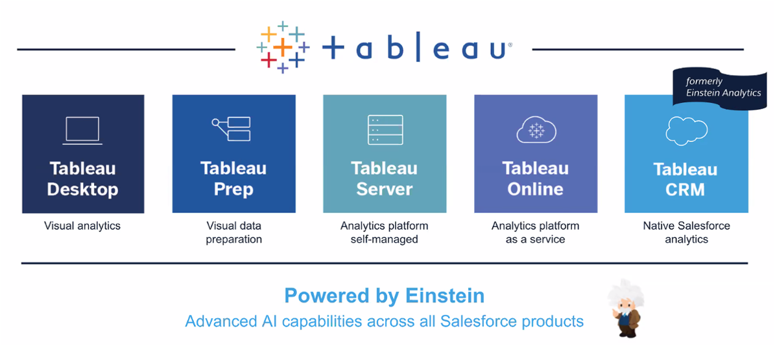

To give some background, the Salesforce TCRM journey began back in 2013, when Salesforce acquired Enterprise BI and Analytics start up, EdgeSpring, which was then branded as Wave and launched in 2014:

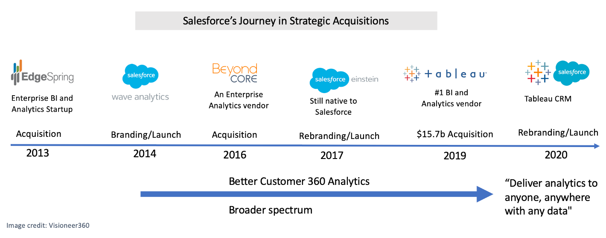

**What is TCRM, and what is it used for?**

#### What is TCRM?

TCRM is not a Salesforce[9] app – TCRM is a business analysis and insights platform.

#### What is it used for?

TCRM is used to extract, aggregate, transform, and visualise data. That is, it is used to take raw information, process it with the aid of business acumen, and tell a story.

For example, as an avid fan of the sport cricket, I found some data online about one day international matches and created a dashboard using TCRM:

What is the purpose of this dashboard? How did I use TRCM in this use case?

1. I loaded the raw data tables into TCRM
2. I combined these tables into one dataset using TCRM
3. I transformed the data to prepare it for visualisation in TCRM
4. I used TRCM to design, build and share the analytics dashboard
5. I was able to “slice and dice” the data, diving into the information to make sense of it and tell a story, with TCRM
6. I

TCRM

## Key Takeaways

1. The role of data and analytics is expanding and becoming more strategic and mission critical in this day of uncertainty.
2. TCRM is used to extract, aggregate, transform, and visualise data

## Questions

1. Does your organisation *excel* at data analytics?

# CHAPTER 2:​ ​

# Where can you use TCRM and get business value from it?

## Room for Improvement

* + Use ideas from Bryan’s MBA
  + Quote statistics re: typical businesses

"Business people are drowning in data and, especially as the complexity of data increases, they are struggling to identify what is most important and what are the best actions to take." – Gartner

## Bigger than oil

## Why TCRM?

## References:

1. Top 10 Trends in Data and Analytics, 2020 – Gartner. Published 11 May 2020 - ID G00718161

1. https://www.gartner.com/en/doc/718161-top-10-trends-in-data-and-analytics-2020
2. https://www.mendix.com/blog/displaying-data-the-right-tools-for-the-right-job/
3. https://www.prnewswire.com/news-releases/the-global-big-data-analytics-market-2027-a-105-billion-opportunity-assessment-301014418.html
4. “Information Dashboard Design”, Stephen Few
5. “Information Dashboard Design”, Stephen Few
6. “Seizing the Information Advantage” – PWC
7. “The age of analytics: Competing in a data-driven world” – McKinsey & Company
8. “Why digital transformation is now on the CEO’s shoulders” – Thomas M. Siebel
9. https://www.salesforce.com/au/products/what-is-salesforce/